 VINOD SIR’S GROUP TUTION

MARKS: 25 MATHS-II TIME: 1 Hr. 30 Mins.

DO AS DIRECTED

1. 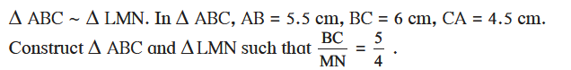
[3]

2. 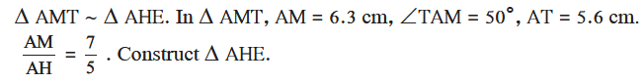[3]

3. Draw a circle of radius 2.7 cm. Draw a tangent to the circle at any point on it. [2]

4. Draw a circle of radius 3.6 cm. Draw a tangent to the circle at any point on it without using the centre. [3]

5. Draw a circle of radius 3.3 cm Draw a chord PQ of length 6.6 cm. Draw tangents to the circle at points P and Q. Write your observation about the tangents [3]

6. Draw a circle with radius 4.1 cm. Construct tangents to the circle from a point at a distance 7.3 cm from the centre. [2]

7. Find the ratio in which point P(k, 7) divides the segment joining A(8, 9) and B(1, 2). Also find k . [3]

8. If A (-14, -10), B(6, -2) is given, find the coordinates of the points which divide segment AB into four equal parts. [3]

9. Show that points P(2, -2), Q(7, 3), R(11, -1) and S (6, -6) are vertices of a parallelogram.
[3]

